[**Object Oriented Programming**](https://classroom.google.com/c/NzE3NTExNTEwOTA5)

**sessional**

**Lab Report -2**

**CSE 1204**

**Problem 1:** **Eligibility Checker for Students**

**Input:**

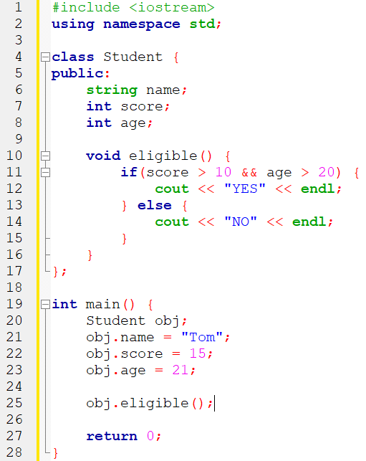

**Output:**



**Problem 2:** **Coding - Rectangle Class Methods**

**Input:**

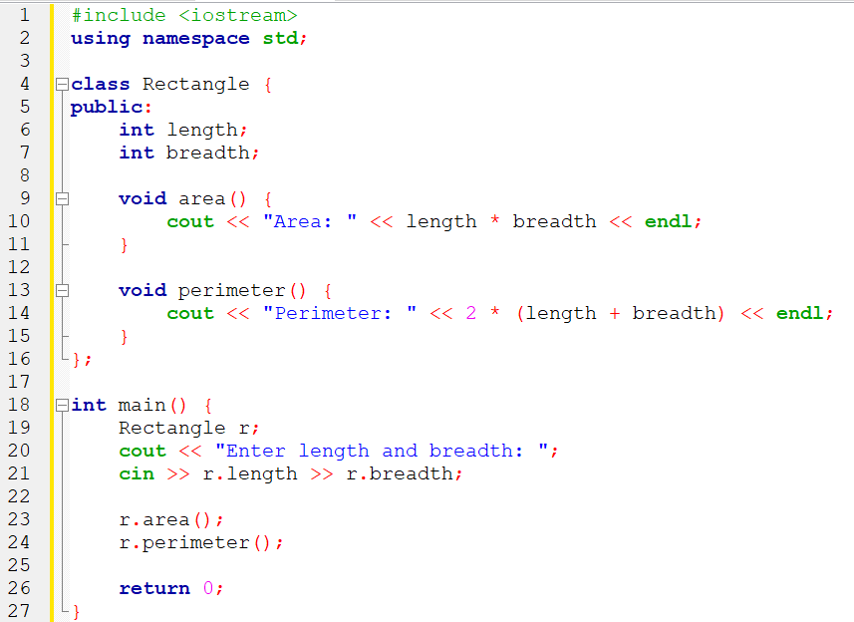

**Output:**

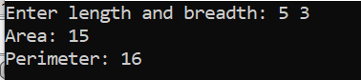

**Problem 3:** **Player BMI Calculation**

**Input:**

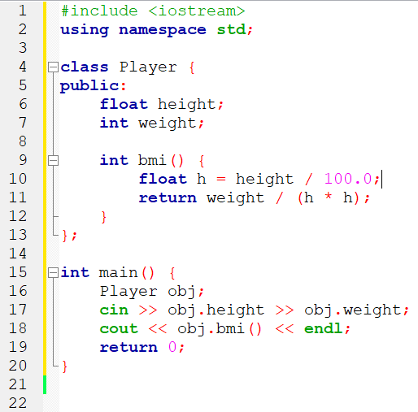

**Output:**

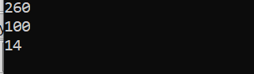

**Problem 4:** **Coding Problem**

**Input:**

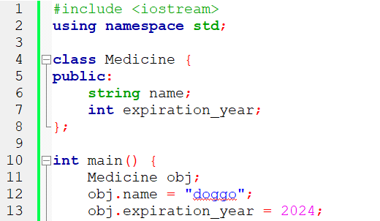

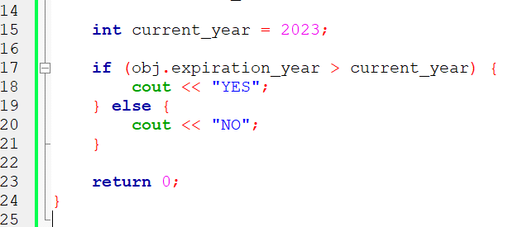

**Output:**



**Problem 5:** **Coding Calculator Class**

**Input:**

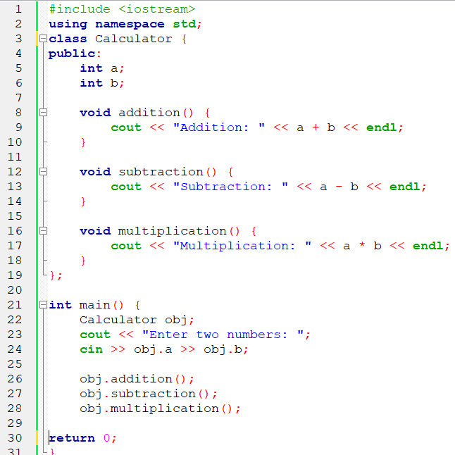

**Output:**

